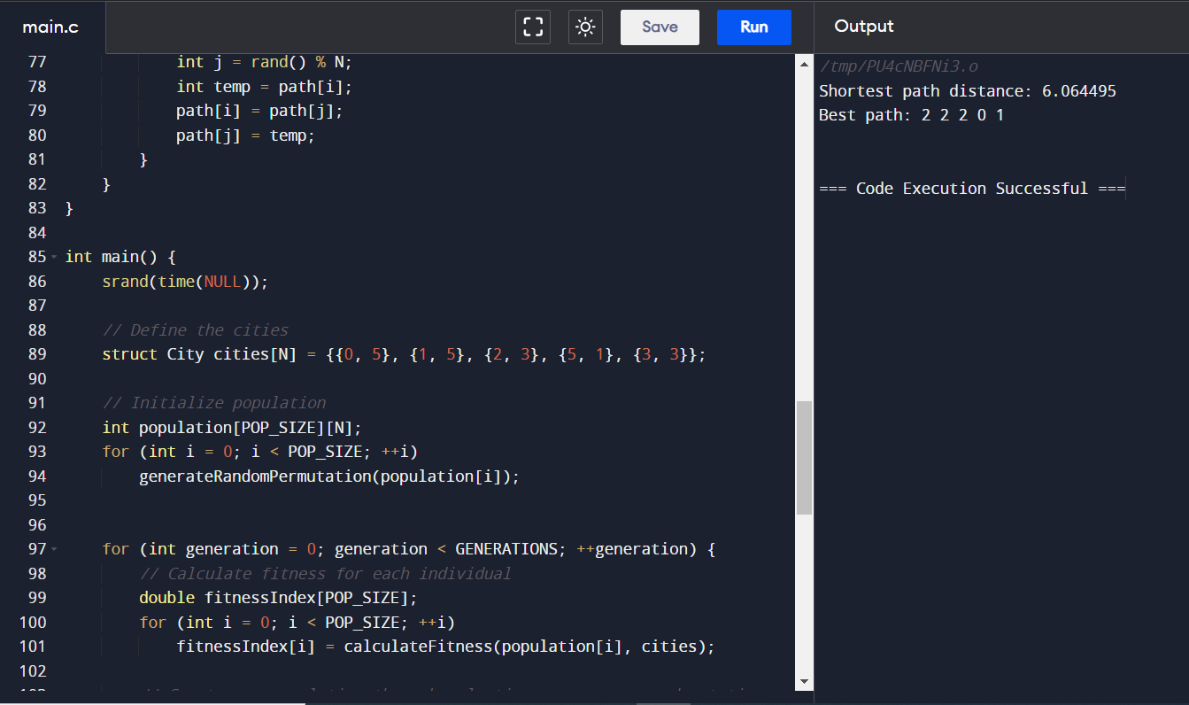

2nd input:(0,1);(1,2);(2,3);(3,4);(4,5)

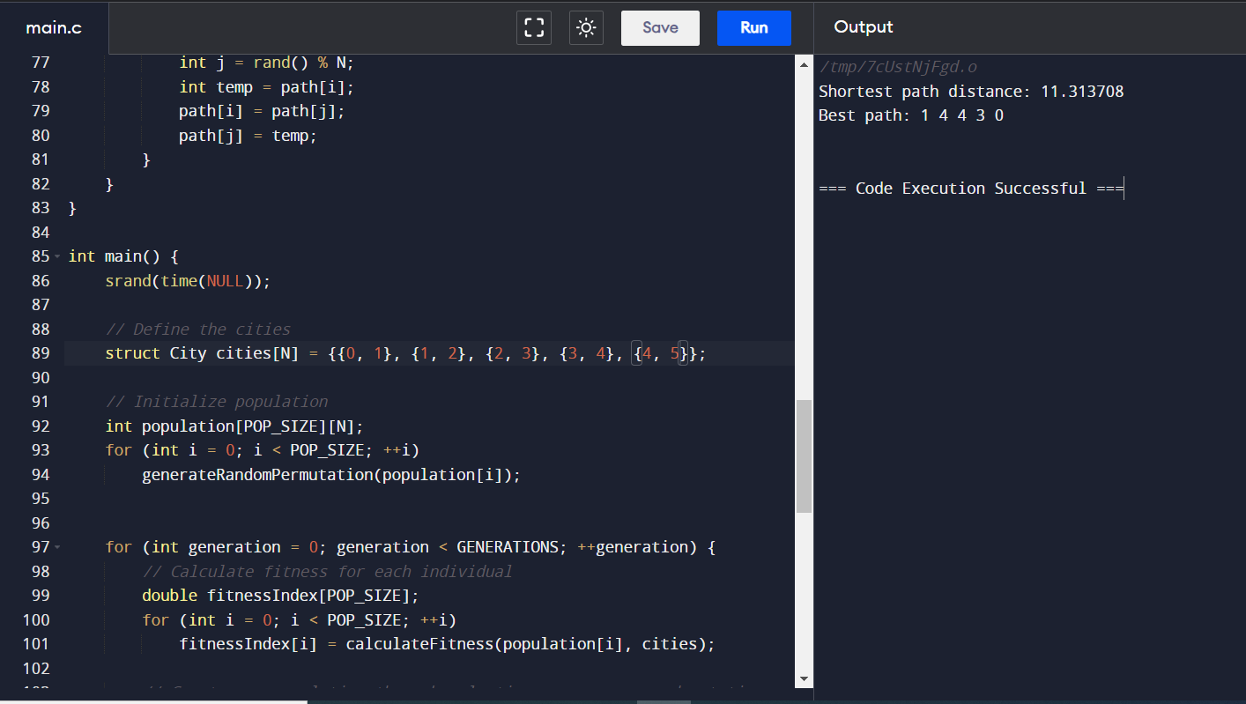

3rd input:(0,0);(1,1);(2,2);(3,3);(4,4)

